**1.Introduction**

The brand-new Waterside campus is a University of Northampton purpose-built campus, designed to provide you with the learning experience and opportunities you expect from a modern university. The University has made large investments in the network infrastructure and other digital services to enhance students’ learning experiences. The IT Services, based at the Learning hub building, manage the network infrastructure.

The Computing department in the Faculty of Art, Science, and Technology, unlike other departments, manages some of its own servers to support computing staff and students. The web server hosts the department website, and also runs the WAMP server to support student work and the File Server to archive student and staff files. The File server also runs user authentication services. Some staff members manage their own websites, e.g., and deliver their modules both through NILE and personal websites. The module material, including weekly work, assessments, and other module-related details, are saved on the file server.

The Engineering and Technology department is interested in replicating the model of the computing department in having their own network.

**1.1)Aims and objective**

The main focus of this project is to design,implement and test a network prototype model for the engineering and technology department.The network prototype should be based/maintain cisco three layer hierarchy.So we are required to replicate the model of the computing department which already has most of the things implemented and is efficient.We need provide a wide range of network which can be accessed by each and every students who are currently in engineering and technology department.We are also to provide different servers(For eg: File server, web server, Application server) so students/teachers can access their things.

**1.2)Development Methodologies**

Development methodology refers to how we are going to develop this project or things we are going to consider while making the project.Following are the methodology we are going to follow creating this project:

**Evaluation:**Since we have been asked to replicate the model based on the computing department which has been running its network very effectively.So we are going to evaluate the model i.e ups and downs of the computing department so we can deliver our work more efficiently for the engineering and technology department.

**Interview:**We will have our interview with Phil Gabel who is working as a network technician for the university.The interview with Phil will help us learn a lot of the network model he wants and we will try to implement every single thing we have learned from him.

**Network prototype:** Based on the requirement mentioned by the network technician and our evaluation of the computing department network model, we will try to provide every feature they want.

**Servers**:We have been asked to provide at least 3 servers(File server, Authentication server, Web server).Staff web pages on the web server with their profiles and module materials saved on the file server. Students, staff and admins will have different privileges and access on the specific servers.Admins will have access to change, edit and upload whereas Teachers can only upload their module activities in their areas.Students can only access their contents.

**Testing**: Network and servers security will be tested to protect the network from hackers who will try to access some crucial data from the servers.We will implement all the security methods to keep the network safe from all the unwanted things.

**2)Requirement Engineering**

So, In this section we will collect all the information required to complete this project.Firstly we will learn a few things from Phil Gabel since he is the network technician for the university.We will also collect a lot of data by searching for problem domains,searching for other comparable systems.

**2.1) Interview plans**

We will be asking a few questions to the network technician of the university to find out what type of network model they want and what are the things he wants us to implement in the system etc.The questions we will be asking the technician are:

| Interviewee | Questions |
| --- | --- |
| Network technician(Phil Gabel) | 1. As you are the network technician for the university, may we know what are the pros and cons of the system that university currently has. 2. Do you just want a network to be implemented in engineering departments only? 3. How much do you want the user capacity of the system to be? 4. Do you need a network connection between the computing and engineering departments to communicate? 5. Which ip class do you think would be preferable in this network? 6. Should we use HSRP (Hot standby routing protocol) to maintain redundancy in the network? 7. Do you want ACL(Access control list) to be implemented in the network? 8. Do you have any idea on what network monitoring tool we should use to monitor network. 9. What backup system do you have at present for storing students and teacher information and what kind of backup system do you want us to create? 10. Beside admin, do you want students and teachers to edit their details as well? 11. How often do you want your system to be updated? 12. What is the allocated budget and timeframe of the system? 13. Do you think there is anything you want to mention we didn't talk about. |

**2.2) Interview Findings**

All the answers we got after having an interview with Phil Gabel are mentioned below:

Interview Date: 08/05/2022

Duration: 20 minutes.

Students attended:

1. Rohan ghimire
2. Pawan Shivakoti
3. Dhanbir Yadav
4. Rupendra thapa
5. Suderson oli
6. Sudarshan Thapa

| Interviewer | Question Number | Questions and Answers |
| --- | --- | --- |
| Pawan Shivakoti | 1 | As you are the network technician for the university, may we know what are the pros and cons of the system that university currently has?  Ans:We are facing a lot of problems right now since we have not been able to provide IP addresses to devices properly.There are difficulties managing network and its software.There is no redundancy in our internet system.There are a lot of problem we are facing due to ransomware and other virus attacks.So, these are mostly the difficulties we are facing right now. |
|  | 2 | Do you just want a network to be implemented in engineering departments only?  Ans: Not really, Actually we want to see the plan for the whole university and segregating the network at the department levels.At least for now we want the network to be implemented in the engineering department. |
|  | 3 | How much do you want the user capacity of the system to be?  Ans: At least network design should be done for 5-10 departments and each department and each department would have at least 1000 users and each department will have different faculties so do your design accordingly. |
| Rohan Ghimire | 4 | Do you need a network connection between the computing and engineering departments to communicate?  Ans: Actually there will be 2 layers one is for within department communication and if you want to go outside the department then definitely there can be communication between them. |
|  | 5 | Which ip class do you think would be preferable in this network?  Ans: You can choose the IP class accordingly since I have already said there will be like 1000 users for a department. |
|  | 6 | Should we use HSRP (Hot standby routing protocol) to maintain redundancy in the network?  Ans: Yes, HSRP is most needed since we are facing a lot of issues due to single point failure. |
|  | 7 | Do you want ACL(Access control list) to be implemented in the network?  Ans: Yes, I want ACL to be implemented to maintain security mechanisms. |
|  | 8 | Do you have any idea on what network monitoring tool we should use to monitor network.  Ans:I don't have particular network monitoring tools in my mind at the moment but you can explore and tell me about the network monitoring tools then I will make a decision from your recommendation. |
|  | 9 | What backup system do you have at present for storing students and teacher information and what kind of backup system do you want us to create?  Ans: Personal information of all users should be encrypted and can only be accessed by admins.For other files and information it will mostly be accessed by anyone so you can add the backup system accordingly.Backup should should be properly maintained on daily basis. |
| Sudershan Oli | 10 | Beside admin, do you want students and teachers to edit their details as well?  Ans: They should not have access to edit any details. |
| Sudarshan thapa | 11 | How often do you want your system to be updated?  Ans: As an industry standard 19 days is the minimum for some updates so we are good to follow the same standard. |
|  | 12 | What is the allocated budget and timeframe of the system?  Ans: You are to provide me with the budget according to the work done and things implemented and we can negotiate about the budget later. |
| Rupendra Thapa | 13 | Do you think there is anything you want to mention we didn't talk about.  Ans: I don't have anything to add right now you can start doing your project and we can have conversation regarding other things later. |

**2.3)Comparable system review**

**2.3.1)Canvas LMS**

To develop our project I looked into a few other systems and I found Canvas LMS decent.So, canvas LMS is a learning management system.It is used by students, tutors to get access to online course materials.The user interface is very eye catchy they have just used simple colours which make the website looks more simple and beautiful..After you join canvas by the join code provided by your instructor/tutor you can see your study materials, tasks to do its due date in the student portal after you have joined some classes.Its a great learning platform for students and instructors as well.

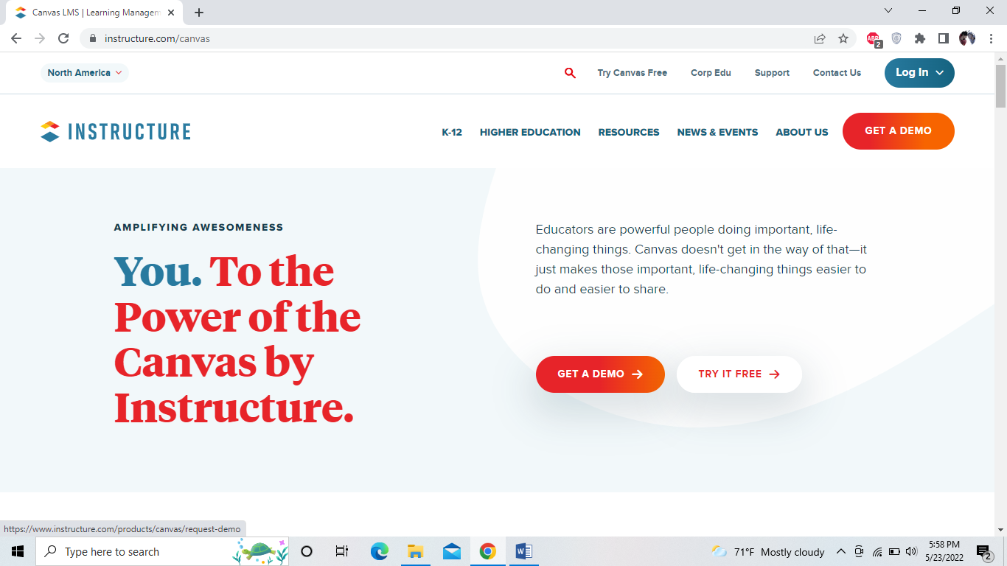

Fig: Canvas LMS

2.3.2) **Blackboard learn**

Blackboard is also a learning management system which has many features for students and tutors.Firstly the interface is very clean and nice.You can login as a student to get access to the course material of your modules.Since my university has collaboration with blackboard we are also using blackboard as a LMS.So, with all the experience i have had using blackboard i can say it's very easy to use, access your course materials upload your assignments etc.Tutors can upload their course materials which can be accessed by students.Students can see their grades of all the tasks they have done and has other many more features.

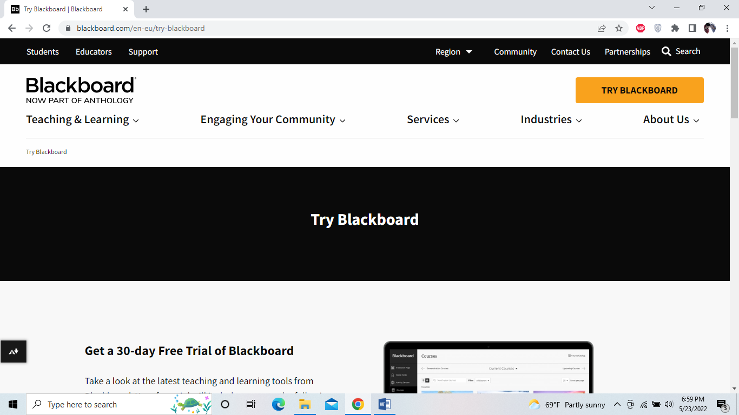

Fig: Blackboard

Below is my student portal of blackboard (NILE).

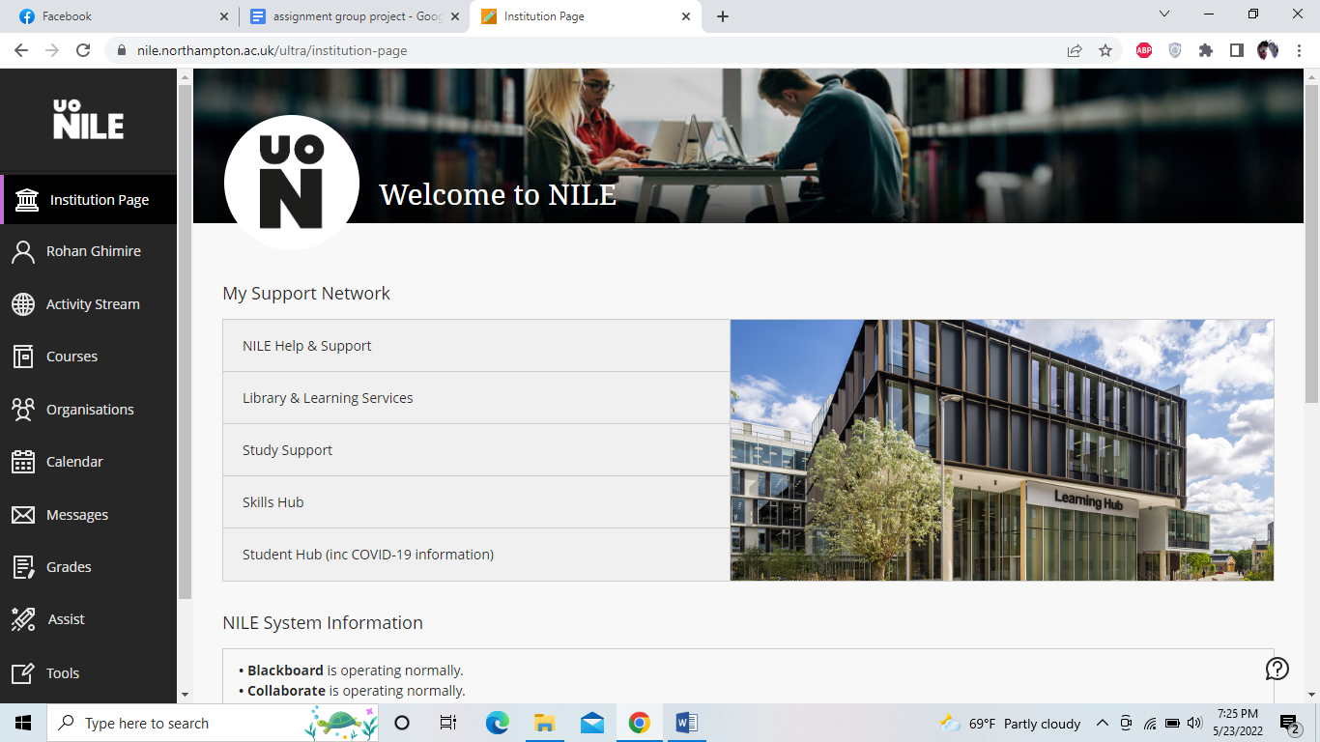

Fig: Student portal Blackboard

**3)Requirements for development**

As everyone knows, to develop a network topology many devices like routers, switches, pcs and wires are required.So, all the requirements to develop our network topology are mentioned below with their respective cost.

| Device | Purpose | Cost |
| --- | --- | --- |
| Router2911(x2) | Needed 2 routers to maintain redundancy in the network so even if a single router fails you can still get access to the internet from another router. | $7100 |
| Switches2960 | Acts as a mediocre device between end devices and routers i.e access layer and distribution layer. | $10000 app. |
| Pcs | To access the network.10 pcs were implemented in our design. | $3000 app. |
| wires | For connectivity between devices | 200-300$ app. |

Software requirements are given below:

| Software | purpose | cost |
| --- | --- | --- |
| WAMP server | WampServer is a web development environment for Windows. It enables the creation of web applications as well as the uploading of files to users and hosting of the website. | free |
| Wireshark | Packet sniffing tool, network analysing tool. | free |
| linux | Testing purposes. | free |
| Nmap | Used to scan IP addresses and ports to find any weaknesses. | free |

So, above are the software we will be using for different purposes and all of them are absolutely free to use.

**3.1)Network planning**

Before designing your network planning is most important.Plans should be made on how are we going to complete the network/what will we use.Since we were required to maintain cisco three layer hierarchy to design the network.Firstly, i created my rough design on MS visio and implemented my design accordingly:

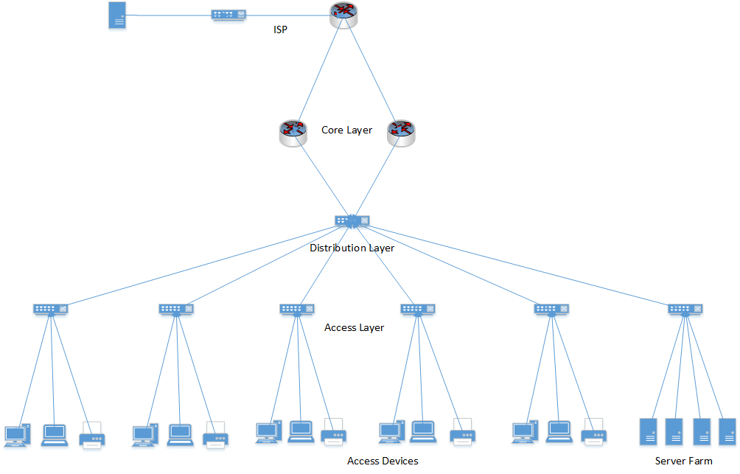

Fig: Network Planning

The above design maintains the rule of cisco three layer hierarchy i.e.(Access layer, Distribution layer, Core layer) and according to our design requirement we are making a design for a department in a university.I have created different branches inside the department for students, staff, admins etc.In the access layer we can see the end devices like pc and access layer switches connected to pcs.In the distribution layer you can see a server switch which transfers its informations to access layer devices and core layer devices.It acts as a bridge between access layer and core layer.In the core layer you can see two routers where i have implemented NAT, HSRP,ACL etc.As you can see there are two routers in the core layer, I have used 2 router to maintain redundancy in the network.So, even if 1 router fails the second one will be active and work.

**3.2) Network design(Logical)**

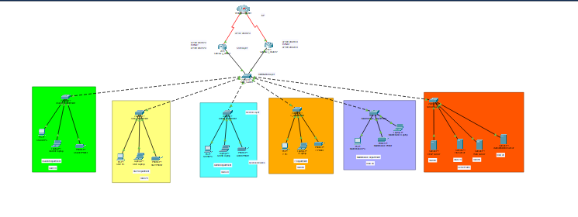

Fig: Network Design

This is the logical network design which I have done in cisco packet tracer.The two routers are connected to Worldlink ISP from the core layer.There is a server switch in the distribution layer and switches and end devices in the access layer.

**3.3) IP addressing scheme**

IP addressing is done according to the requirement mentioned by Network technician.In 1 department there will be at least 1000 users so for the engineering and technology department there will be at least 2000 users using the network so we have provided ip to each branch accordingly.

| VLAN | DEPARTMENT | Network add | SubnetMask | Usable IP range | broadcast |
| --- | --- | --- | --- | --- | --- |
| 10 | Student | 172.16.0.0 | 255.255.248.0 | 172.16.0.1-172.16.7.254 | 172.16.7.255 |
| 20 | Staff | 172.16.8.0 | 255.255.255.128 | 172.16.8.1-172.16.8.126 | 17216.8.127 |
| 30 | Admin | 172.16.8.128 | 255.255.255.240 | 172.16.8.129-172.16.8.142 | 172.16.8.143 |
| 40 | Maintenance | 172.16.8.144 | 255.255.255.240 | 172.16.8.145-172.16.8.158 | 172.16.8.159 |
| 50 | It | 172.16.8.160 | 255.255.255.240 | 172.16.8.161-172.16.8.174 | 172.16.8.175 |
| 60 | DHCP | 172.16.8.176 | 255.255.255.248 | 172.16.8.177-172.16.8.182 | 172.16.8.183 |
| 70 | File server | 172.16.8.184 | 255.255.255.248 | 172.16.8.185-172.16.8.190 | 172.16.8.191 |
| 80 | Web server | 172.16.8.192 | 255.255.255.248 | 172.16.8.193-172.16.8.198 | 172.16.8.199 |
| 90 | Auth server | 172.16.8.200 | 255.255.255.248 | 172.16.8.201-172.16.8.206 | 172.16.8.207 |
| 100 | VTP | 172.16.8.208 | 255.255.255.240 | 172.16.8.209-172.16.8.222 | 172.16.8.223 |

**VLANs**

A VLAN is a specialised network consisting of one or more LANs.It enables the consolidation of devices from multiple networks into a single logical network..The below image shows all the VLAN i have created for all branches inside the engineering and technology department.

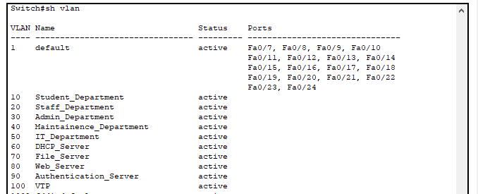

**Fig: VLANs**

**VTP**

Virtual trunking protocol(VTP) is used by switches to exchange information between switches.To configure VTP you should make a switch as a server switch where you will configure everything and other switches as client switches and what you have configured on the server switch will be reflected in client switches.

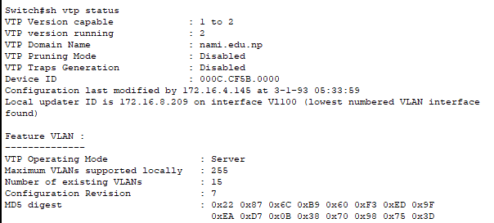

Fig:VTP (Server switch)

**L2 security(Port security)**

Port security has been implemented on each and every port of switches on access layers connected to pcs.The port security type is restrict so if any unwanted port sends a request to switch the packet won't forward anywhere it will just drop.

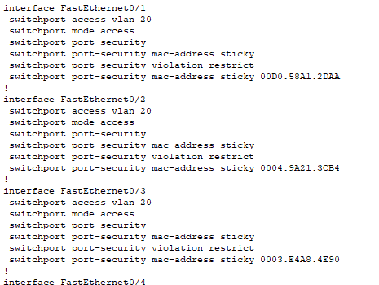

**DHCP snooping**

DHCP snooping is another layer 2 security configuration configured in switches.You can configure which port to trust so if any untrusted port sends a request the request won't pass, Only trusted ports will be able to send and receive information.

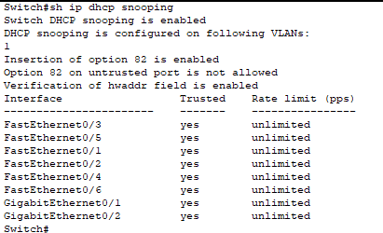

**NAT**

Network address translation(NAT) translates private IP into a single public ip so every device can access the internet.I have implemented NAT in both of the routers.IP nat outside is configured on serial port of router which leads to internet connection and Ip nat inside is configured on Gig sub interfaces of router/internal network.

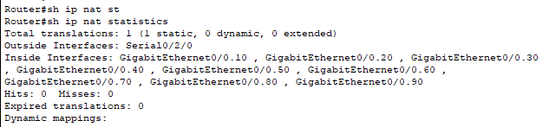

**HSRP**

HSRP is mostly used to make networks redundant.You can make one router as an active router and other as a standby router so if your active router fails the standby router will be active.

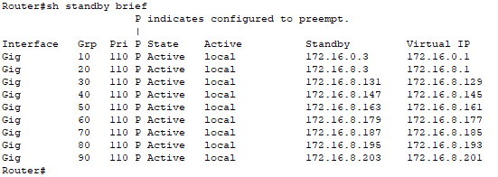

**ACL**

ACL is a set of rules that deny or grant permission to a network.It is used for providing security.You can make restrictions for a network you want in the interface of a router.



**4) Implementation**

**4.1) Windows server Installation**

So we have downloaded Windows Server 2012 R2 on the vmware workstation.There are a lot of options before installing/setting up windows server.We chose windows server standard GUI based which is easier to work on.

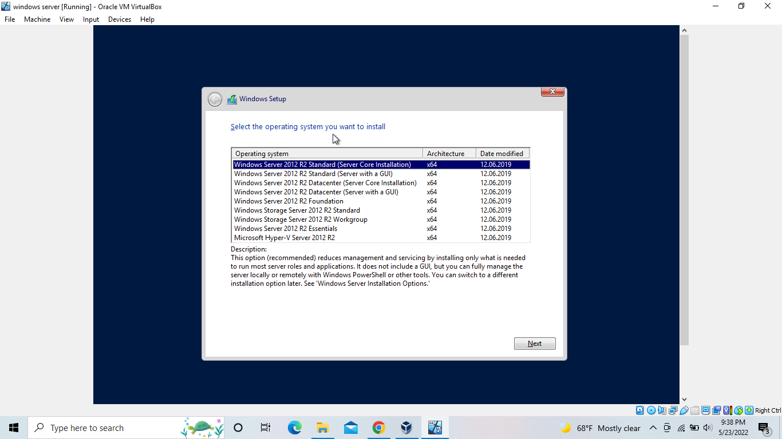

Fig: Server selection for installation

**4.2)Configuring server**

After the successful installation of the server we got into the server management portal.

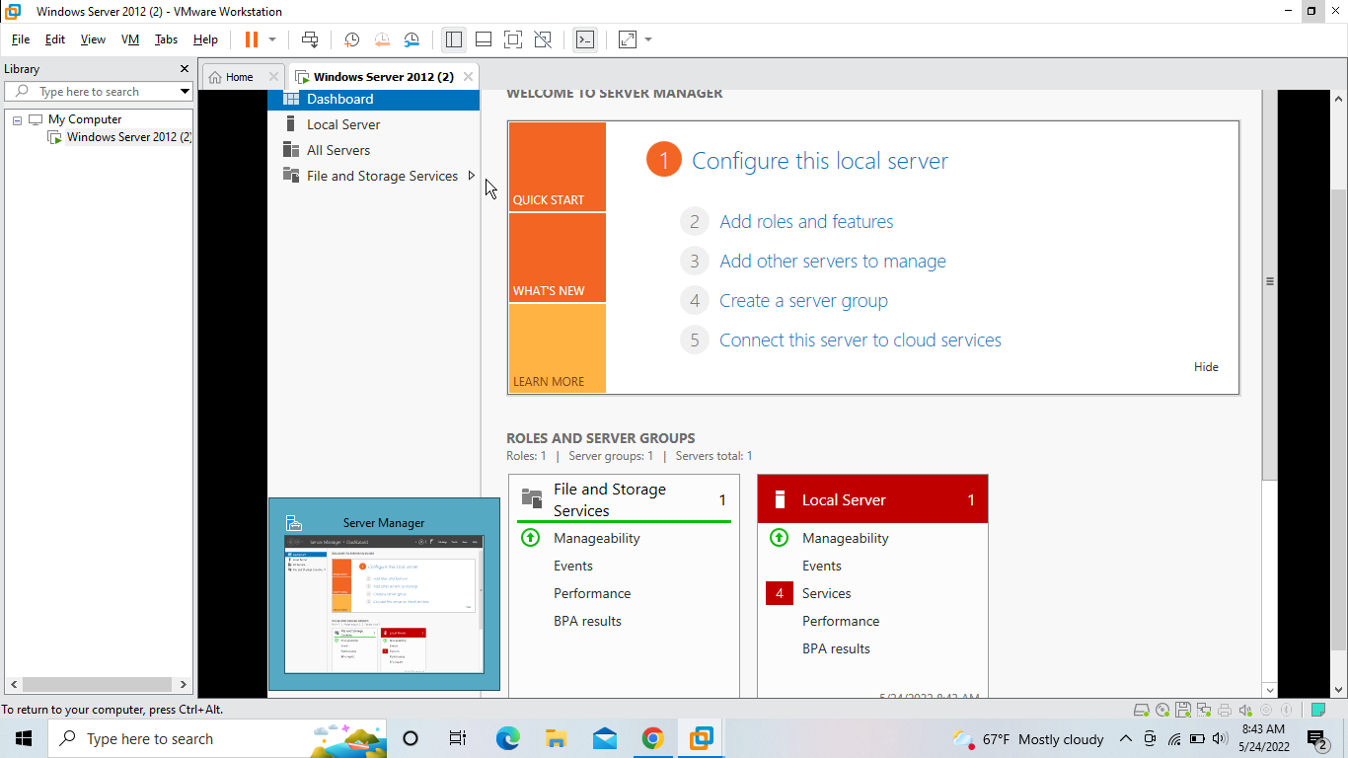

**Fig: Server management window**